FORM 5
THE PATENTS ACT, 1970
(39 of 1970)
and
THE PATENTS RULES, 2003
STATEMENT AND UNDERTAKING UNDER SECTION 8
(See section 10(6) and Rule 13(6))
1. NAME OF THE APPLICANT(S). | SHAH SHASHWAT NIMESH  SHAH KRUTI BHAVESH  GUPTA MANASVI GANESH  JOBANPUTRA KHUSHI DHARMENDRA
hereby declare that the true and first inventor(s) of the invention disclosed in the complete specification filed in the pursuance of my/our application numbered Dated: 15th October 2024, Tuesday is/are
2. INVENTOR(S)
NAME: SHAH SHASHWAT NIMESH
NATIONALITY : INDIAN
ADDRESS : A/1606, SHREEPATI CASTLE, KHETWADI, GRANT ROAD(E) MAHARASHTRA.
MUMBAI - 400004
Dated : 10th May 2025, Saturday
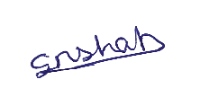
Signature:-
Name of Signatory:- SHAH SHASHWAT NIMESH

NAME: SHAH KRUTI BHAVESH
NATIONALITY : INDIAN
ADDRESS: 17, 3rd FLOOR,HIMGIRI BUILDING, PEDDAR ROAD, GRANT ROAD (W) MAHARASHTRA.
MUMBAI-400026.
Dated: 10th May 2025, Saturday
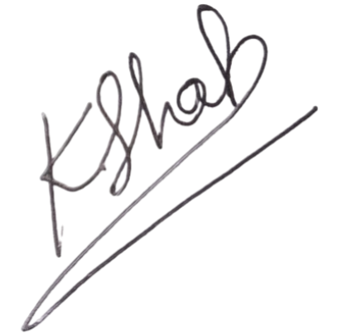
Signature:-
Name of Signatory:- SHAH KRUTI BHAVESH

NAME: GUPTA MANASVI GANESH
NATIONALITY : INDIAN
ADDRESS: 49, OM NARBADESHWAR NIWAS NEAR M.S.E.B SUBSTATION BORADE MALLA JAIL ROAD MAHARASHTRA.
NASHIK-422101.
Dated : 10th May 2025, Saturday
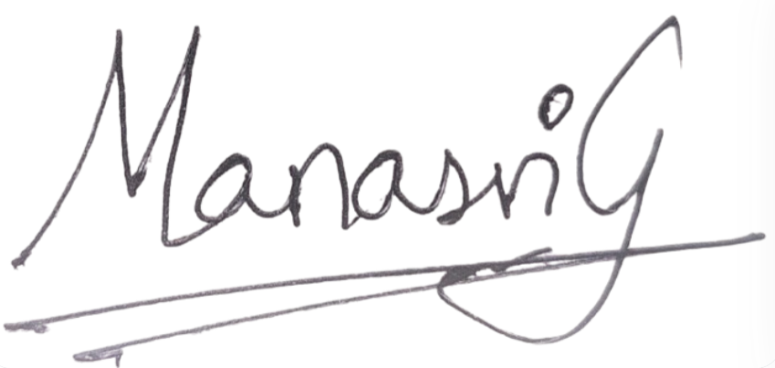
Signature:-
Name of Signatory:- GUPTA MANASVI GANESH

NAME: JOBANPUTRA KHUSHI DHARMENDRA
NATIONALITY : INDIAN
ADDRESS: 902, SHRI DATTA DIGAMBER CHS LTD CHANDAVARKAR ROAD
BORIVALI (W) MAHARASHTRA.
MUMBAI- 400092.
Dated : 10th May 2025, Saturday
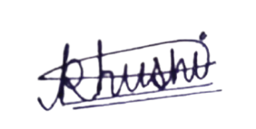
Signature:-
Name of Signatory:- DHARMENDRA KHUSHI JOBANPUTRA
NAME: KARANI RUHINA
NATIONALITY : INDIAN
ADDRESS: A1/10, AIR INDIA COLONY, PLOT NO-24, SECTOR 27, SEAWOODS EAST, LANDMARK NEAR APOLLO HOSPITAL MAHARASHTRA.
NAVI MUMBAI-400706
Dated : 10th May 2025, Saturday
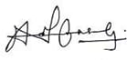
Signature:-
Name of Signatory:- KARANI RUHINA
SHAH SHASHWAT NIMESH
Applicant

To,
The controller of Patent
The Patent Office, at Mumbai/Delhi/Chennai/Kolkata

